**NOC**

Form

1. Login as sugar mill -> EA -> NOC -> Add new record -> without entering depot name and quantity, click on save as draft/submit -> following error page is displayed.

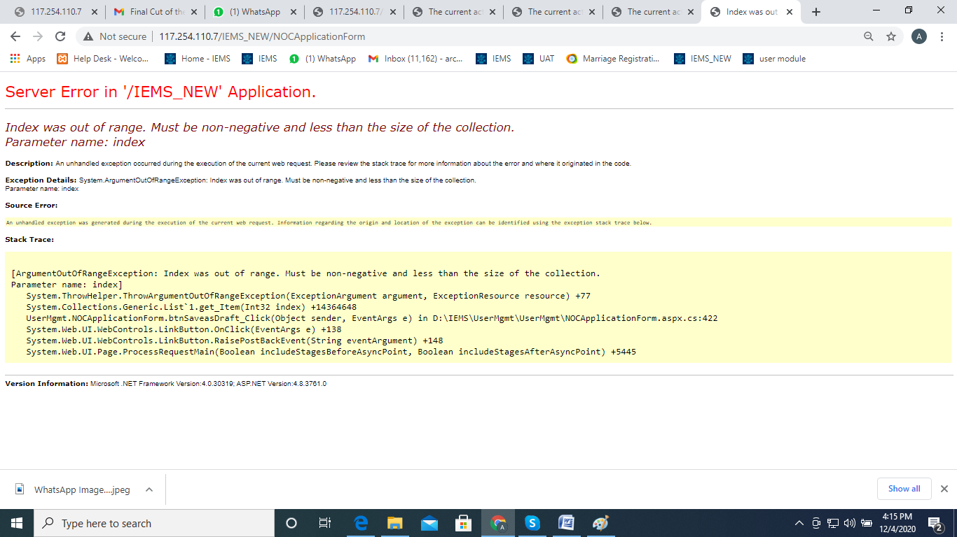

1. Login as Sugar Mill -> EA -> Add new record -> “valid date upto” field is mandatory without entering the date record get submitted -> From noc application list view -> view the same record -> following error page is displayed :

Expected result : user should notify with an alert upto to enter the valid date

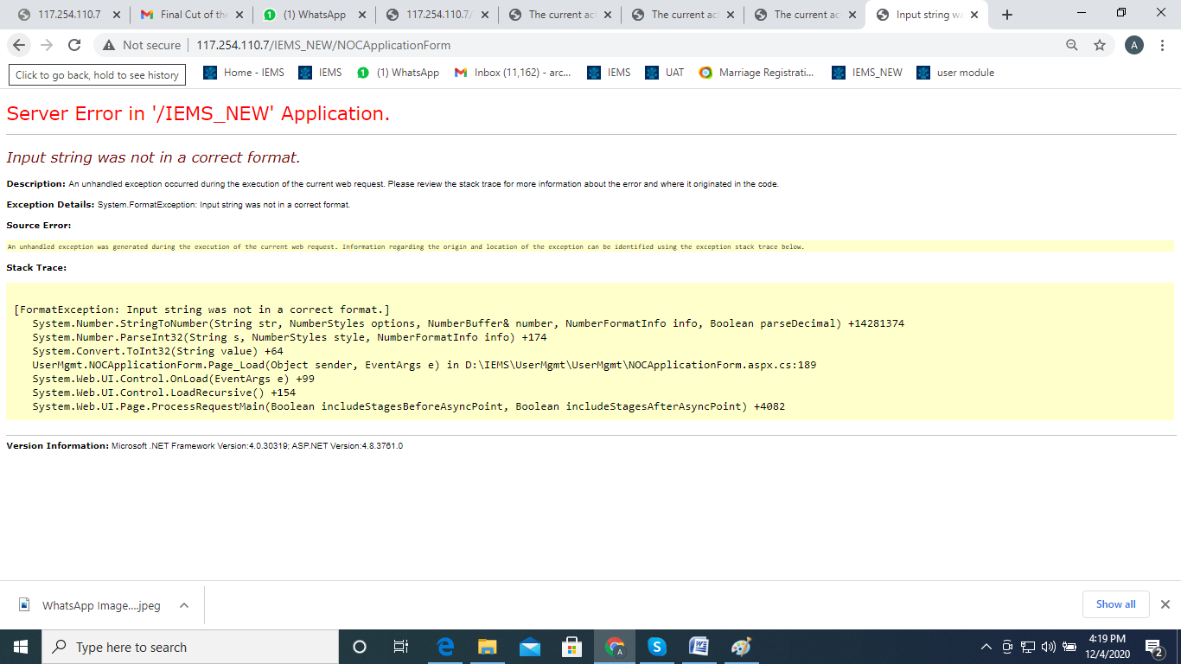

1. Raising first NOC record in Hpcl_ec sugar mill--> NOC Number is displayed as 4 instead of 1.

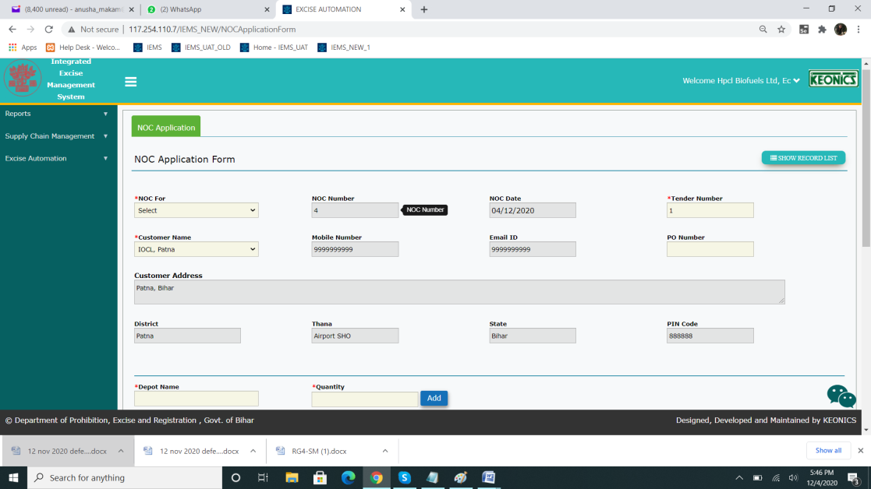

4. An alert pop-up needs to alert the user to enter document description if document is attached. Currently, able to attach without any description(Blank).

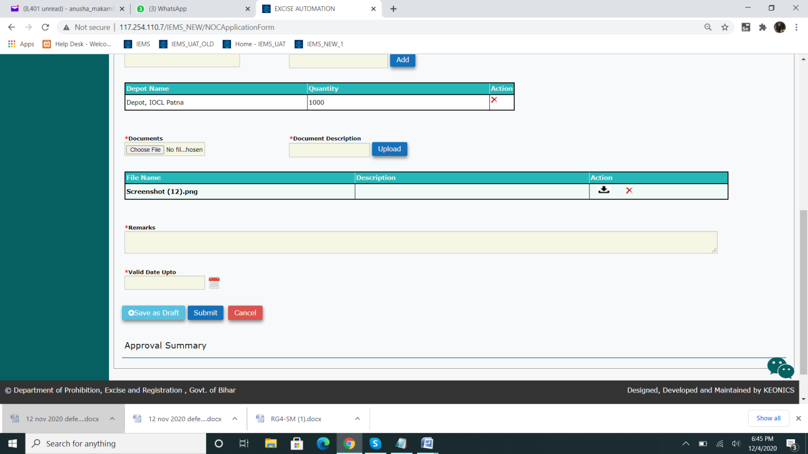

5.If NOC for field is not selected and submitted-->The following po-up reappears and doesn't allow to submit the record

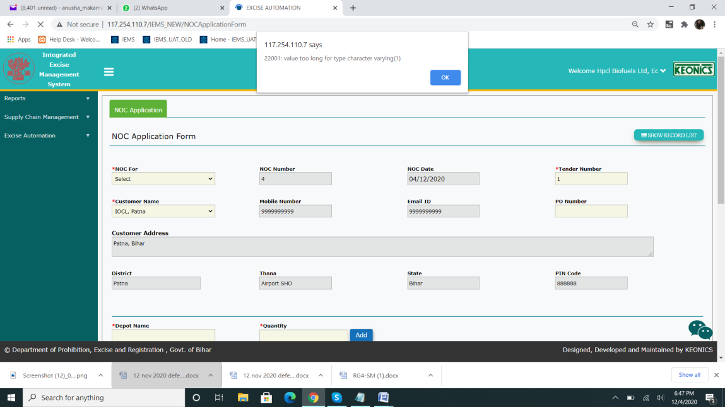

6. NOC depot qty doesnt accept decimal values. The error appears.



8.In assistant commissioner login(ecedo)---> Able to view all other NOC records created in Sitamahri(riga). A restriction should be imposed based on the district.

The numbers 4,5 belong to East Champaran.

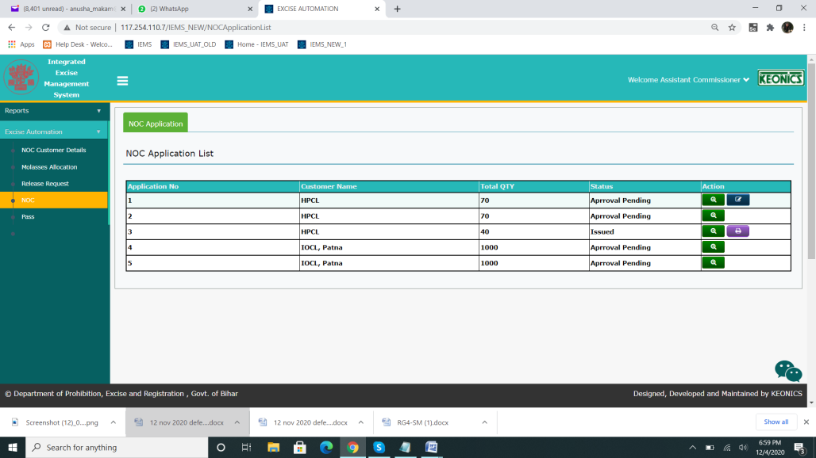

9. Login as riga _sgr -> EA -> NOC-> draft record also displayed for Assistant commissioner for approval

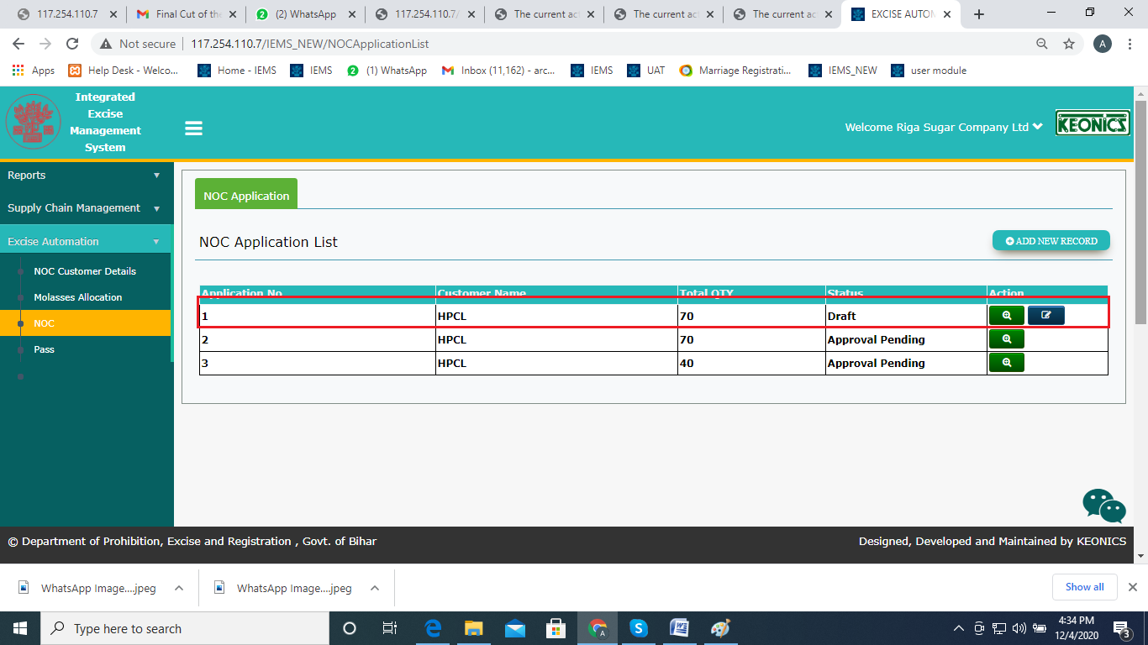

10. Requires alert pop-ups for all mandatory fields--->NOC For, Depot, Qty, Documents(Marked mandatory as per ui, not sure of requirements), Remarks, Valid Upto.(User sugar mill login)

11. sitedo -> NOC -> draft record also displayed with status “approval pending “

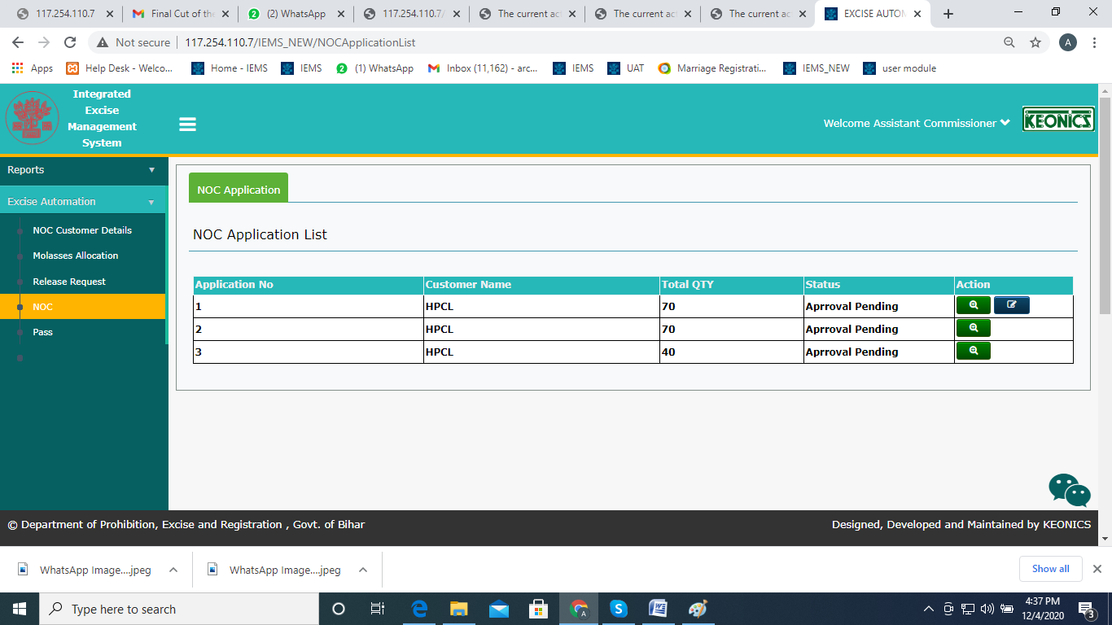

12. On rejecting a record at ecedo login, the Assistant commissioner is able to edit the record and save the record. The user screen appears. This screen should be visible only to the user.(Reject flow blocker)

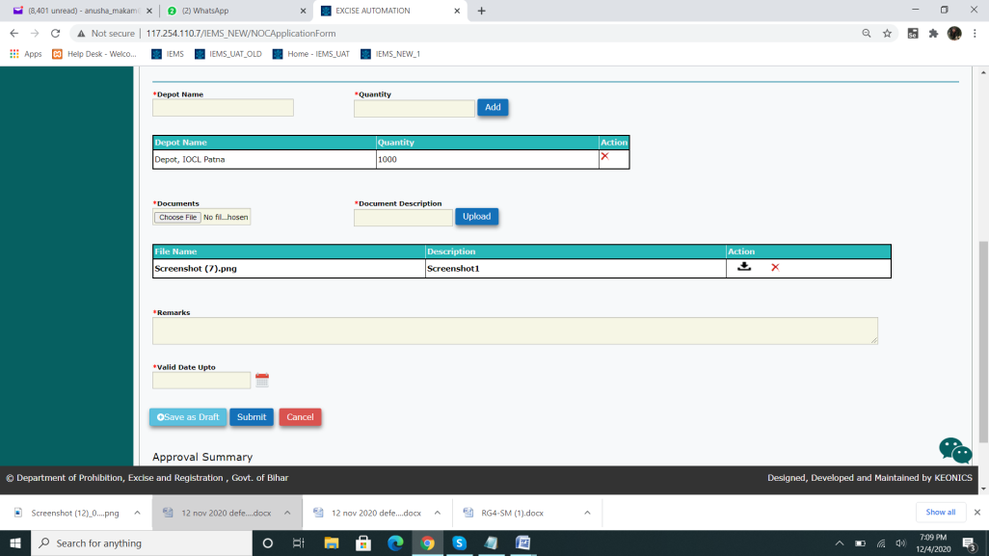

13. login as hodyco -> EA -> NOC -> view -> with out selecting “valid date upto” field-> record get saved in hodyco login -> Expected result : alert pop up need be displayed as it mandatory field.

Remarks and Valid Upto fields require an alert pop-up.

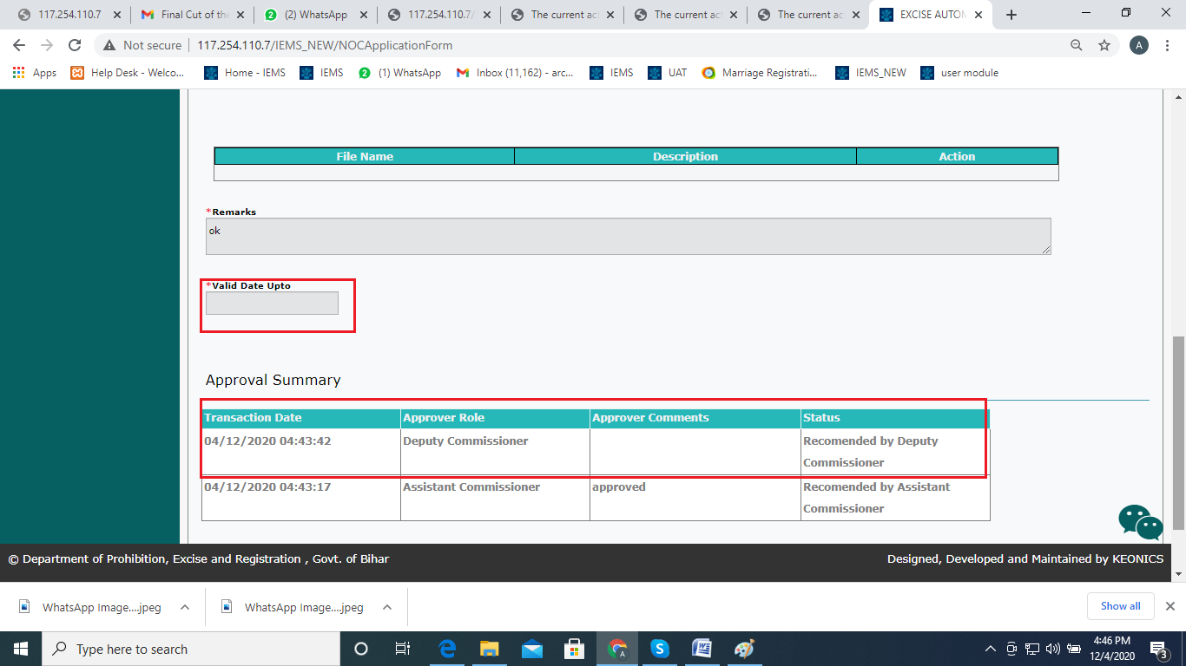

14) In commissioner login, the remarks field requires an alert pop-up for the mandatory field.

15)Only if Valid date is not entered, displays only Refer back option at commissioner login. Else Approve and Reject options are displayed.

16)Login as riga_sgr/hodyco/commissioner ->EA->NOC-> NOC application list -> click on print-> values are not displayed in report

